Lab 08

- )

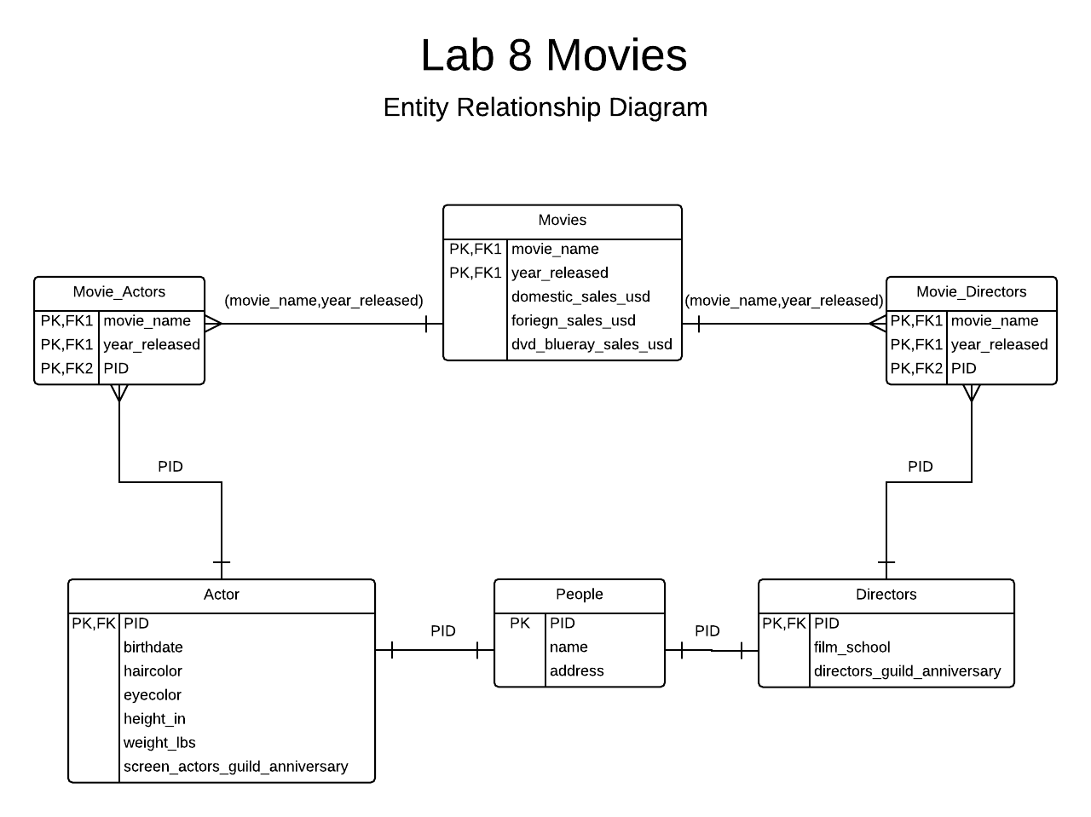
- )

CREATE TABLE Movies (
movie_name text not null,
year_released smallint CHECK(year_released > 1800),
domestic_sales_usd numeric(12,2),
foriegn_sales_usd numeric(12,2),
dvd_blueray_sales_usd numeric(12,2),
PRIMARY KEY(movie_name,year_released)
);

CREATE TABLE People(
pid char(6) not null,
name text not null,
address text,
PRIMARY KEY(pid)
);

CREATE TABLE Actors (
pid char(6) not null REFERENCES People(pid),
birthdate date,
eyecolor char(15),
haircolor char(15),
height_in smallint CHECK(height_in > 0),
weight_lbs smallint CHECK(weight_lbs > 0),
screen_actors_guild_anniversary date,
PRIMARY KEY(pid)
);

CREATE TABLE Directors(
pid char(6) not null REFERENCES People(pid),
film_school text,
directors_guild_anniversary date,
PRIMARY KEY(pid)
);

CREATE TABLE Movie_Actors(
movie_name text not null,
year_released smallint not null,
pid char(6) not null REFERENCES Actors(pid),
FOREIGN KEY(movie_name,year_released) REFERENCES Movies(movie_name,year_released),
PRIMARY KEY(movie_name,year_released,pid)
);

CREATE TABLE Movie_Directors(
movie_name text not null,
year_released smallint not null,
pid char(6) not null REFERENCES Directors(pid),
FOREIGN KEY(movie_name,year_released) REFERENCES Movies(movie_name,year_released),
PRIMARY KEY(movie_name,year_released,pid)
);

- )

INSERT INTO Movies(movie_name,year_released,domestic_sales_usd,foriegn_sales_usd,dvd_blueray_sales_usd)
VALUES('Entrapment',1999,87704396.00,124700000.00, 1500000.00),
('Finding Forrester',2000, 51768623.00 , 28245000.00,1245555.00 ),
('The League of Extraordinary Gentlemen',2003, 66465204.00, 112800000.00, 36400000.00 ),
('GoldenEye',1995,106429941.00,245764093.00,22389000.00);

INSERT INTO People(pid,name,address)
VALUES('p1','Sean Connery','Fake Addres 3033, Podunk, NW 32113'),
('p2','Catherine Zeta-Jones','2108 Elm Street, Ellenvile, NY 10482'),
('p3','Rob Brown','6792 Pine Road, Trentown, NJ 39802'),
('p4','Stuart Townsend','1293 Empire Ave, Taconic, NY 31123'),
('p5','Pierce Brosnan','9321 High Street, Pheonix, AZ 11234'),
('p6','Jon Amiel','8203 Underwood Road, Endstown, WZ 32393'),
('p7','Gus Van Sant','Fake Addres 3033, Podunk, NW 32113'),
('p8','Stephen Norrington','3829 Infinite Ion Ave., Nowville, TX 00789'),
('p9','Martin Campbell','9987 End Of Line Road, Final Town, GA 23225');

INSERT INTO Actors(pid,birthdate,haircolor,eyecolor,height_in,weight_lbs,screen_actors_guild_anniversary)
VALUES('p1', '08-25-1930','brown' ,'brown', 56, 216,'06-18-1954' ),
('p2','07-12-1976','blond','blue',60,120,'07-01-1995'),
('p3','11-25-1980','black','green',67,140,'02-03-1990'),
('p4','02-06-1984','red','hazel',53,210,'04-07-1997'),
('p5','05-21-1970','brown','red',57,175,'08-21-1982');

INSERT INTO Directors(pid,film_school,directors_guild_anniversary)
VALUES('p6','University of Cambridge','03-24-1982'),
('p7','Film School Of Nowhereville','11-11-1990'),
('p8','Bright Eyes School Of Movies','09-01-1995'),
('p9','The World Of Film','12-30-1987');

INSERT INTO Movie_Actors(movie_name,year_released,pid)
VALUES('Entrapment',1999,'p1'),
('Entrapment',1999,'p2'),
('Finding Forrester',2000,'p1'),
('Finding Forrester',2000,'p3'),
('The League of Extraordinary Gentlemen',2003,'p1'),
('The League of Extraordinary Gentlemen',2003,'p4'),
('GoldenEye',1995,'p5');

INSERT INTO Movie_Directors(movie_name,year_released,pid)
VALUES('Entrapment',1999,'p6'),
('Finding Forrester',2000,'p7'),
('The League of Extraordinary Gentlemen',2003,'p8'),
('GoldenEye',1995,'p9');

- ) Movies
(movie_name, year_released) -> the set and all subsets of {domestic_sales_usd, foriegn_sales_usd, dvd_blueray_sales_dvd}

People
pid -> the set and all subsets of {name, address}
as in theory there could be two "Hosea Rodrigez" at the same address

Actors
pid -> the set and all subsets of {birthdate, haircolor, eyecolor, height_in, weight_lbs, screen_actors_guild_anniversary}

Directors
pid-> the set and all subsets of {film_school, directors_guild_anniversary}

Movie Actors
(movie_name,year_released,pid) -> * None *

Movie Directors
(movie_name,year_released,pid) -> * None *

- )
select distinct DirectorsJoin.name as "Directors Name" from movies
inner join movie_directors on movie_directors.movie_name = movies.movie_name AND movie_directors.year_released = movie_directors.year_released
inner join movie_actors on movie_actors.movie_name = movies.movie_name AND movie_actors.year_released = movie_actors.year_released
inner join people as ActorsJoin on ActorsJoin.pid = movie_actors.pid
inner join people as DirectorsJoin on DirectorsJoin.pid = movie_directors.pid
where ActorsJoin.name = 'Sean Connery'
order by DirectorsJoin.name asc;

